**Practical no. 1**

**FS19CO042**

**Aim:**

Getting started with Java Application Development using IDE

1.1 Check whether latest version of java (at least JDK 1.8)is installed or not. If not then download and install it.

1.2 Download and install the IntelliJ IDEA Community Edition/ NetBeans IDE 8.1/ Eclipse Neon or later version of IDE

1.3 Create a Java Project/ Application in the IDE

1.4 Create a Java class Person containing two variables name and yearOfBirth of appropriate data types, take inputs from the command line argument, a method to display the name and age of the person.

1.5 Save the project and run it.

1.6 Explore all the features (the menu and shortcuts) of the IDE. Learn about their use

**Tool used:** Editor (Notepad/Intellij IDE), JDK and JRE

**Theory:**

**Java**

Java is a programming language created by James Gosling from Sun Microsystems (Sun) in 1991. The target of Java is to write a program once and then run this program on multiple operating systems. The first publicly available version of Java (Java 1.0) was released in 1995. Sun Microsystems was acquired by the Oracle Corporation in 2010. Oracle has now the steermanship for Java. In 2006 Sun started to make Java available under the GNU General Public License (GPL). Oracle continues this project called OpenJDK.

[**Java virtual machine**](https://www.vogella.com/tutorials/JavaIntroduction/article.html#java-virtual-machine) **(JVM)**

The Java virtual machine (JVM) is a software implementation of a computer that executes programs like a real machine.  
The Java virtual machine is written specifically for a specific operating system, e.g., for Linux a special implementation is required as well as for Windows.

Java programs are compiled by the Java compiler into bytecode. The Java virtual machine interprets this bytecode and executes the Java program

**Java Development kit (JDK)**

The JDK additionally contains the development tools necessary to create Java programs. The JDK therefore consists of a Java compiler, the Java virtual machine and the Java class libraries

Java program workflow:

javac hello.java -> Compiles java source file into a class file and new hello.class file is generated  
java hello -> Executes class file generated in java virtual machine.

Base structure of Java program:  
package test;  
class Hello{

public static void main(String[] args){

// Code goes here

}

}

**Steps:**

**1.1 Check whether latest version of Java (at least JDK 1.8) is installed or not. If not then download and install it.**

* Check if java compiler(javac) and jvm (java) are installed properly on system.  
  Type these commands:  
  javac -version  
  java -version

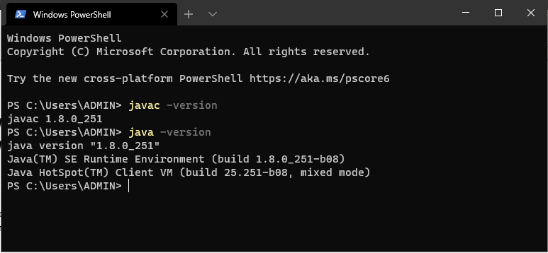

* If java compiler or jvm is not installed on system, download executibles from Oracle.com and execute to install JDK.
* Set environment variables to path where java is installed.  
  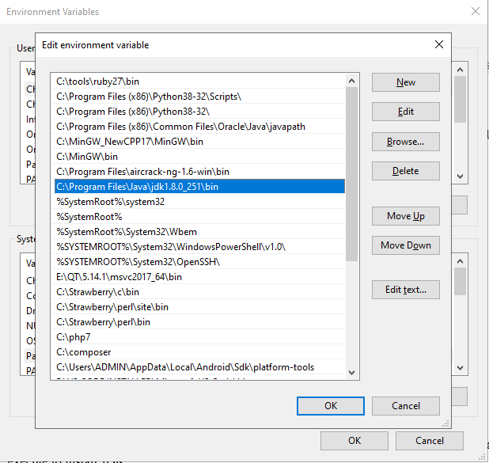

**1.2 Download and install the IntelliJ IDEA Community Edition/ NetBeans IDE 8.1/ Eclipse Neon or later version of IDE**

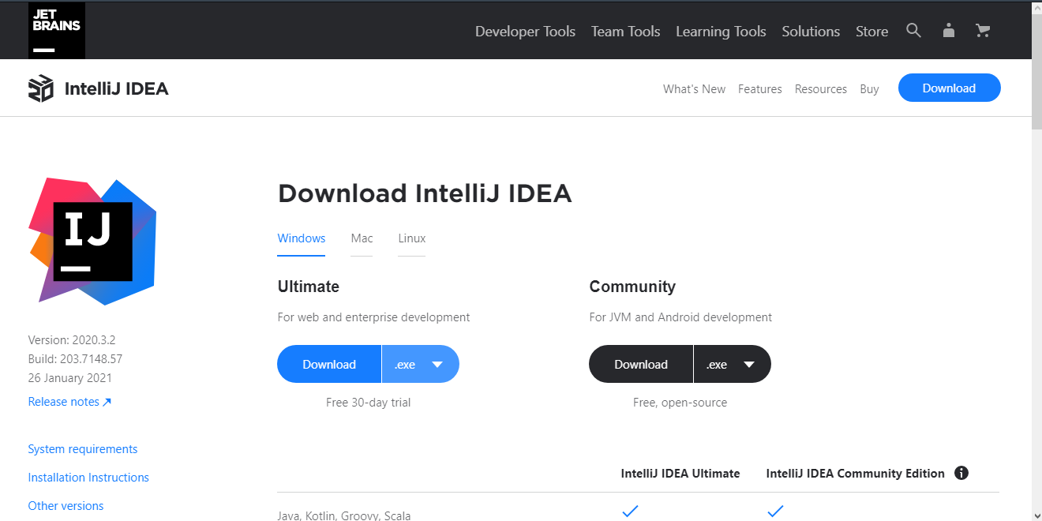

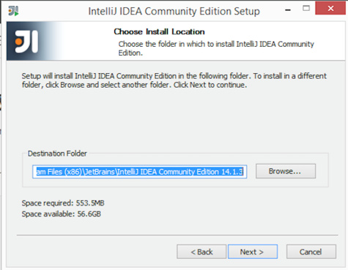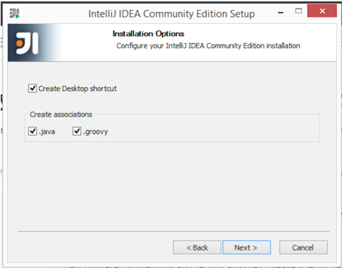

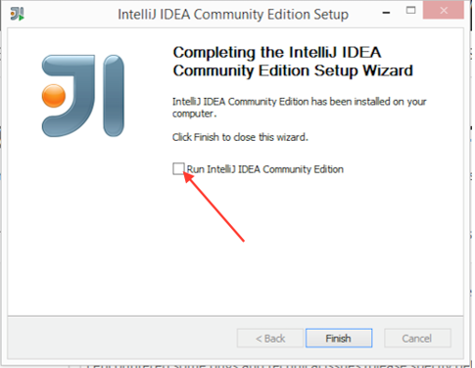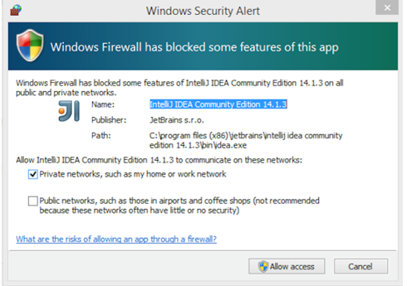

**1.3 Create a Java Project/ Application in the IDE**

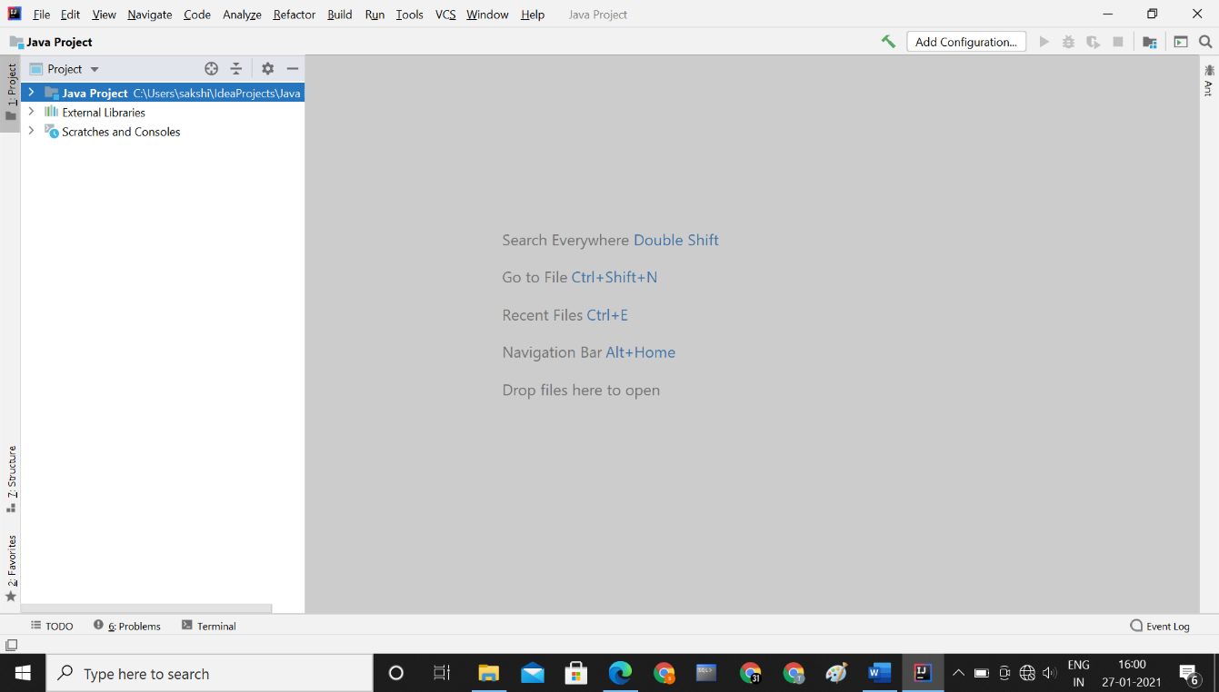

**1.4 Create a Java class Person containing two variables name and yearOfBirth of appropriate data types, take inputs from the command line argument, a method to display the name and age of the person.**

public class Person  
{  
 String name;  
 int yearOfBirth;  
 public static void disp_details(String a,int b)  
 {  
 int current_year=2021;  
 int age=current_year-b;  
 System.out.println("name is "+a+" and age is "+age);  
  
 }  
 public static void main(String [] args )  
 {  
 disp_details("sakshi",2004);  
 }  
}

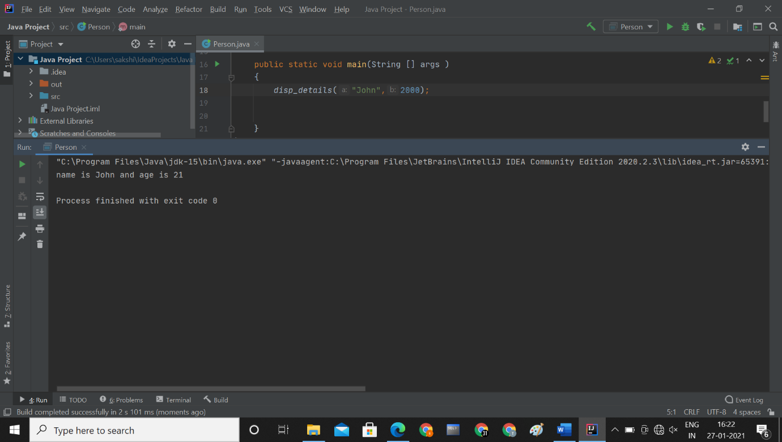

**1.5 Save the project and run it.**

**Conclusion: Thus, we verified/installed java and IntelliJ IDE and ran first program on it. We also explored various features of the IDE.**